## 环境：

Master：

操作系统:centOS

[mysql-test@master ~]$ cat /proc/version

Linux version 2.6.32-696.el6.x86_64 (mockbuild@c1bm.rdu2.centos.org) (gcc version 4.4.7 20120313 (Red Hat 4.4.7-18) (GCC) ) #1 SMP Tue Mar 21 19:29:05 UTC 2017

增加用户mysqler,设置密码，在mysqler的家目录下下载安装mysql

[hadoop@master ~]$ su //切换到root

[root@master hadoop]# useradd mysqler #添加用户mysqler

[root@master hadoop]# passwd mysqler #为用户mysqler设置密码

将mysqler添加到sudo权限便于安装软件：

[root@master mysql-test]# vim /etc/sudoers #编辑sodoers文件

添加：mysqler ALL=(ALL) ALL

[root@master mysql-test]# su mysqler

[mysqler @master ~]$ cd

[mysqler@master ~]$ mkdir app src

[mysqler@master ~]$ ls

app src

mysql最新社区版下载网址：<https://dev.mysql.com/downloads/mysql/>

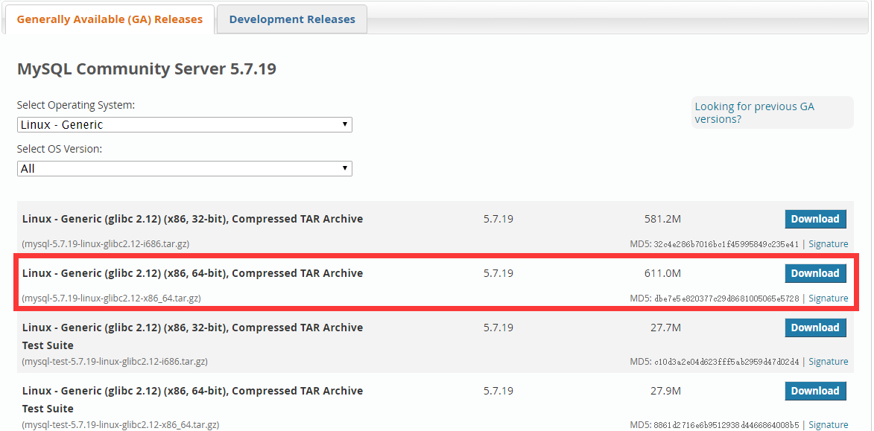根据自己的系统选择合适的版本，这里选择：**Linux - Generic (glibc 2.12) (x86, 64-bit), Compressed TAR Archive**

**下载链接地址为：**<https://dev.mysql.com/get/Downloads/MySQL-5.7/mysql-5.7.19-linux-glibc2.12-x86_64.tar.gz>

到master机器上，mysqler的家目录下的src中：

[mysqler@master src]$ wget <https://dev.mysql.com/get/Downloads/MySQL-5.7/mysql-5.7.19-linux-glibc2.12-x86_64.tar.gz>

等待下载完成

然后解压二进制压缩包到指定的目录：

[mysqler @master app]$ tar -xzvf mysql-5.7.19-linux-glibc2.12-x86_64.tar.gz -C ../app

[mysqler @master app]$ cd ..

为包做个软连接（就相当于windows里面的快捷方式）

[mysqler@master app]$ ln -s mysql-5.7.19-linux-glibc2.12-x86_64 mysql

[mysqler@master app]$ ll

total 4

lrwxrwxrwx 1 mysqler mysqler 35 Aug 17 23:02 mysql -> mysql-5.7.19-linux-glibc2.12-x86_64

drwxrwxr-x 9 mysqler mysqler 4096 Aug 17 22:59 mysql-5.7.19-linux-glibc2.12-x86_64

进入到mysql

[mysqler@master app]$ cd mysql

[mysqler@master mysql]$ ls

bin COPYING docs include lib man README share support-files

执行：

[mysqler@master mysql]$ ./bin/mysql_install_db --user=mysqler

2017-08-17 23:04:25 [WARNING] mysql_install_db is deprecated. Please consider switching to mysqld --initialize

2017-08-17 23:04:25 [ERROR] The data directory needs to be specified.

有一个提醒和一个报错

提醒是因为：新版的mysql初始化数据库变了，正如它的提示：使用mysqld –initialize

错误是因为：我们没有指定放数据文件的路径

那么我们在此目录下建立data目录，作为数据文件的路径，该路径下在执行初始化工作之前不能有任何其他的文件

在/usr/local下执行安装

[root@master local]# ls

bin games lib libexec mysql-5.7.19-linux-glibc2.12-x86_64.tar.gz sbin src

etc include lib64 mysql-5.7.19-linux-glibc2.12-x86_64 openresty share

[root@master local]# ln -s mysql-5.7.19-linux-glibc2.12-x86_64 mysql

[root@master local]# ls

bin games lib libexec mysql-5.7.19-linux-glibc2.12-x86_64 openresty share

etc include lib64 mysql mysql-5.7.19-linux-glibc2.12-x86_64.tar.gz sbin src

[root@master local]# cd mysql

[root@master mysql]# ls

bin COPYING docs include lib man README share support-files

[root@master mysql]# ll

total 52

drwxr-xr-x 2 root root 4096 Aug 18 00:07 bin

-rw-r--r-- 1 7161 31415 17987 Jun 22 07:13 COPYING

drwxr-xr-x 2 root root 4096 Aug 18 00:07 docs

drwxr-xr-x 3 root root 4096 Aug 18 00:07 include

drwxr-xr-x 5 root root 4096 Aug 18 00:07 lib

drwxr-xr-x 4 root root 4096 Aug 18 00:07 man

-rw-r--r-- 1 7161 31415 2478 Jun 22 07:13 README

drwxr-xr-x 28 root root 4096 Aug 18 00:07 share

drwxr-xr-x 2 root root 4096 Aug 18 00:07 support-files

[root@master mysql]# chown -R mysql:mysql .

[root@master mysql]# ll

total 52

drwxr-xr-x 2 mysql mysql 4096 Aug 18 00:07 bin

-rw-r--r-- 1 mysql mysql 17987 Jun 22 07:13 COPYING

drwxr-xr-x 2 mysql mysql 4096 Aug 18 00:07 docs

drwxr-xr-x 3 mysql mysql 4096 Aug 18 00:07 include

drwxr-xr-x 5 mysql mysql 4096 Aug 18 00:07 lib

drwxr-xr-x 4 mysql mysql 4096 Aug 18 00:07 man

-rw-r--r-- 1 mysql mysql 2478 Jun 22 07:13 README

drwxr-xr-x 28 mysql mysql 4096 Aug 18 00:07 share

drwxr-xr-x 2 mysql mysql 4096 Aug 18 00:07 support-files

数据初始化

[root@master mysql]# ./bin/mysqld --initialize --datadir=./data --user=mysql

2017-08-18T07:10:23.311265Z 0 [Warning] TIMESTAMP with implicit DEFAULT value is deprecated. Please use --explicit_defaults_for_timestamp server option (see documentation for more details).

2017-08-18T07:10:23.526025Z 0 [Warning] InnoDB: New log files created, LSN=45790

2017-08-18T07:10:23.567612Z 0 [Warning] InnoDB: Creating foreign key constraint system tables.

2017-08-18T07:10:23.702179Z 0 [Warning] No existing UUID has been found, so we assume that this is the first time that this server has been started. Generating a new UUID: 4dac7dc1-83e4-11e7-86c7-000c2973734f.

2017-08-18T07:10:23.703464Z 0 [Warning] Gtid table is not ready to be used. Table 'mysql.gtid_executed' cannot be opened.

2017-08-18T07:10:23.705298Z 1 [Note] A temporary password is generated for root@localhost: vAyNa7?iz/;c

**/tem/mysql.sock 必须是 生成的mysqld.sock**

简单的配置：

[mysqld]

# changes to the binary log between backups.

log_bin

# These are commonly set, remove the # and set as required.

basedir = /data/service/mysql-5.7.10

datadir = /data/mysql3306

port = 3306

server_id = 100

socket = /tmp/mysqld.sock

启动：

[root@master local]# sudo ./bin/mysqld_safe --defaults-file=./conf/my.cnf

登录：

[root@master mysql]# ./bin/mysql -uroot -p

Enter password:

Welcome to the MySQL monitor. Commands end with ; or \g.

Your MySQL connection id is 3

Server version: 5.7.19-log

Copyright (c) 2000, 2017, Oracle and/or its affiliates. All rights reserved.

Oracle is a registered trademark of Oracle Corporation and/or its

affiliates. Other names may be trademarks of their respective

owners.

Type 'help;' or '\h' for help. Type '\c' to clear the current input statement.

mysql>

第一次使用的是临时密码。登录后要修改密码

Mysql> set password for 'root'@'localhost'=password('newpasswd');

新的版本的mysqld服务器需要先初始化：

创建data目录，我放在了mysql解压目录：

[mysqler @master mysql-5.7.19-linux-glibc2.12-x86_64]$ mkdir data

初始化数据库：

[mysqler @master mysql-5.7.19-linux-glibc2.12-x86_64]$ ./bin/mysql_install_db --user=mysql --basedir=./ --datadir=./data